


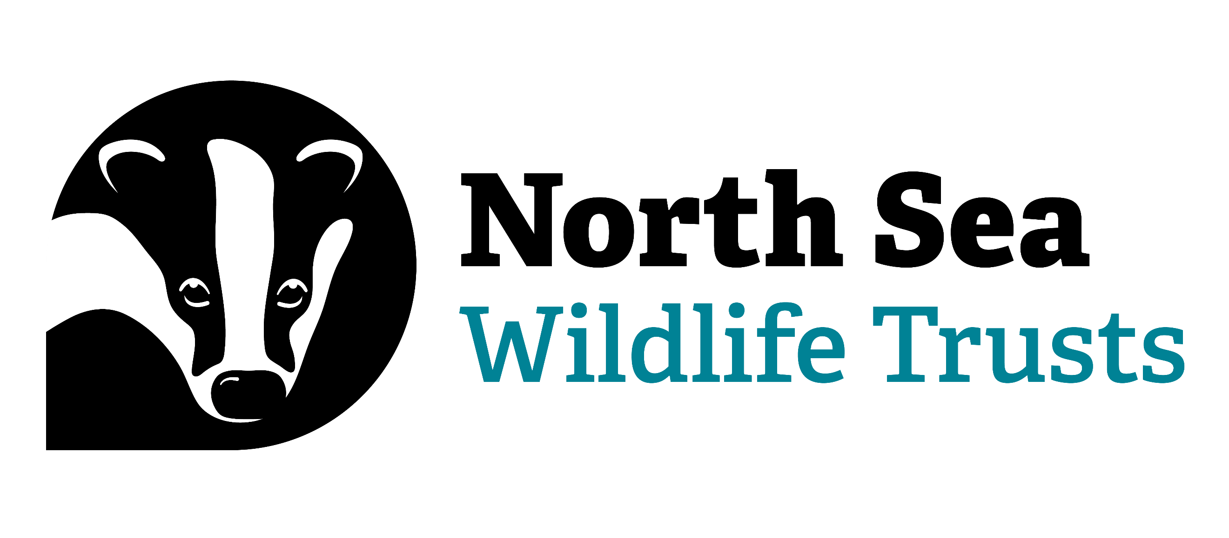
Job Description

Job Title: | Marine Futures North Sea East Coast Intern x 2
Weekly Hours: | 35
Duration of contract: | Full-time, fixed term for 6 months
Location: | Horncastle, Lincolnshire (flexible working) with some travel across the North Sea East Coast and further afield
Reports To: | Head of Conservation
Job Purpose:
The Marine Futures Internship North Sea East Coast Programme will offer a unique opportunity to gain skills, knowledge and on-the-job experience across a variety of sectors in the marine environment. The internship programme is funded by The Crown Estate and is hosted by Lincolnshire Wildlife Trust. It is in partnership with the North Sea Wildlife Trusts, Ørsted and Natural England; offering experience and a balanced view on a career in the marine environment and how different sectors can work together. Each of the two interns will get the chance to undertake an independent research project focussing on a topic that is relevant to partners, and one joint project with their fellow intern. Additional activities will include stakeholder engagement, participating in educational outreach and ecological fieldwork. Delivering presentations, understanding health & safety at work; and participating in online meetings, training, conferences and webinars will be included too.
Special Features of the Role:
- To undertake a joint and independent research project for the partner organisations
- To communicate the outcomes and recommendations from the research projects through a written report and oral presentation for all partner organisations and relevant stakeholders
- To gain a greater understanding of careers relating to the marine sector
- To improve knowledge of renewable energy developments and some of the environmental, social and economic considerations associated with these
- To gain a thorough understanding of some of the environmental issues facing UK coasts and seas, especially in relation to the North Sea and the East Coast of England
- To gain scientific survey and GIS experience alongside the partner organisations
- To gain an understanding of casework
- To deliver marine awareness and educational outreach
- To assist partners with key conservation and restoration projects
- To gain greater insight into the consenting process of activities at sea and on the coast
- To gain an understanding of remote working and online meetings by working with colleagues from each of the partner organisations, building a network of contacts in the marine sector

Person Specification

1 Qualifications & Experience:
The post holder will be expected to have qualifications or proven experience in the following areas:

 |  | Essential | Desirable
 | A degree, apprenticeship or relevant experience in the marine or environmental sector | •
 | Experience of working or volunteering in the environmental sector |  | •
 | Experience of working or volunteering in the UK’s marine environment |  | •
 | Experience of event organisation and delivery |  | •
 | Experience of using media comms to represent an organisation and/or in scientific communication (including social media, blogs etc.) |  | •
 | Experience conducting independent desk-based research |  | •

2 Knowledge & Skills:
The post holder will have the following knowledge and skills:

 |  | Essential | Desirable
 | Demonstrable knowledge of and an interest in current marine conservation, renewable energy, climate change and/or sustainable fisheries issues | •
 | Knowledge and understanding of marine resources and sea users | •
 | Excellent communication skills (written and verbal), with an ability to build strong working relationships and to engage with people at all levels, internally and externally | •
 | Excellent organisational skills with an ability to identify priorities and manage variable workloads, whilst maintaining high level of accuracy and attention to detail | •
 | Highly self-motivated with drive and determination to succeed | •
 | Knowledge of stakeholder engagement |  | •
 | Full driving licence and use of own vehicle | •
 | Knowledge of UK marine species and habitats |  | •

3 Personal Qualities:
The post holder should possess the following:

 |  | Essential | Desirable
 | A keen interest and passion for the marine environment | •
 | Desire and commitment to gain practical, ‘on-the-job’ skills | •
 | Willingness to work outdoors on a range of sites in all weathers | •
 | Self-discipline and confidence in own abilities | •
 | Ability to make sound, clear decisions that are well-considered and in line with the core values of the partner organisations | •

Terms and Conditions

- Salary: £24,479 pa pro-rata plus a generous pension contribution.

- Duration of post: 5 days per week for 6 months starting 15 June 2026 and finishing 11 December 2026. Interns will be expected to commit to the full length of the programme.

- The two interns will be full-time (35 hour week). The salary offered is £24,479 pa pro-rata. There is a flexible hours system in operation. Weekend and Bank Holiday work may occasionally be necessary for which time off in lieu is allowed.

- The annual leave entitlement is 23 days plus Bank Holidays and three privilege days at Christmas.

- In addition, a generous contributory pension scheme is offered, plus an enhanced sick pay scheme and life assurance. A salary exchange system for child care vouchers and the cycle to work scheme is also operated, and an independent and confidential staff welfare support service is provided.

- Place of work: Horncastle, Lincolnshire, with a mixture of office working and field work across the North Sea East Coast. At times there will be the need for travel to/from London. Lincolnshire Wildlife Trust provides a rewarding and enjoyable working environment, that is friendly and open to all.

- Interns will be expected to arrange and pay for their own accommodation and travel to/from work for the duration of the internship.

Interns will be reimbursed for travel and subsistence as part of the programme from their place of work (for instance when travelling for events, meetings and surveys). In some circumstances, additional subsistence expenses may be incurred in connection with the programme, these will be reimbursed where appropriate in line with Lincolnshire Wildlife Trust’s expenses policy and approval must be sought from the Project Manager before expenditure.

All travel and accommodation requirements for trips to London (if possible during the internship) will be covered by The Crown Estate. Any additional expenses, where reasonable, such as subsistence for travel to London, will be reimbursed.

- Completed application forms should be returned via email to: marinefutures@cumbriawildlifetrust.org.uk

- Only short-listed candidates will be contacted. If you have not heard anything within 14 days of the closing date, please assume your application has not been successful.

- Closing date for applications is Midnight Sunday 12 April 2026.

- Interviews will be held on 7-8 May 2026 in Horncastle.

- Applicants shortlisted for an interview will be asked to declare any unspent criminal convictions.

- Any further enquiries should be directed to Tammy Smalley, Head of Conservation via email: hr@lincstrust.co.uk

